Specification document for the encoding of the models relative to task 1.3.3 “Encode models”

- MODEL NAME
Mechanism-based PK–PD model for the prolactin biological system response following an acute dopamine inhibition challenge: quantitative extrapolation to humans.

- GENERAL INFORMATIONS
  - Reference(s)
Jasper Stevens, Bart A. Ploeger, Margareta Hammarlund-Udenaes, Gunilla Osswald, Piet H. van der Graaf, Meindert Danhof , Elizabeth C. M. de Lange. J. Pharmacokinet. Pharmacodyn., DOI 10.1007/s10928-012-9262-4

  - Abstract
The aim of this investigation was to develop a mechanism-based pharmacokinetic-pharmacodynamic (PK-PD) model for the biological system prolactin response following a dopamine inhibition challenge using remoxipride as a paradigm compound. After assessment of baseline variation in prolactin concentrations, the prolactin response of remoxipride was measured following 1) single intravenous doses of 4, 8 and 16 mg/kg and 2) following double dosing of 3.8 mg/kg with different time intervals. The mechanistic PK-PD model consisted of: i) a PK model for remoxipride concentrations in brain extracellular fluid; ii) a pool model incorporating prolactin synthesis, storage in lactotrophs, release into- and elimination from plasma; iii) a positive feedback component interconnecting prolactin plasma concentrations and prolactin synthesis; and iv) a dopamine antagonism component interconnecting remoxipride brain extracellular fluid concentrations and stimulation of prolactin release. The most important findings were that the free brain concentration drives the prolactin release into plasma and that the positive feedback on prolactin synthesis in the lactotrophs, in contrast to the negative feedback in the previous models on the PK-PD correlation of remoxipride. An external validation was performed using a dataset obtained in rats following intranasal administration of 4, 8, or 16 mg/kg remoxipride. Following simulation of human remoxipride brain extracellular fluid concentrations, pharmacodynamic extrapolation from rat to humans was performed, using allometric scaling in combination with independent information on the values of biological system specific parameters as prior knowledge. The PK-PD model successfully predicted the system prolactin response in humans, indicating that positive feedback on prolactin synthesis and allometric scaling thereof could be a new feature in describing complex homeostatic mechanisms.

  - Short summary

PK-PD model building and random variability
Nonlinear mixed effect modeling using NONMEM (version VI, level 2.0 Icon Development Solutions, Ellicott City, Maryland, USA) was used for modeling of the single- and double intravenous remoxipride administration studies.
A sequential PK-PD modeling approach was applied, in which the individual PK parameters were fixed to the posthoc parameter estimates from the previously published population PK model for remoxipride in rat plasma and brain ECF after intravenous and intranasal administration.
The structural model building in this paper was performed under ADVAN 9, and the first order conditional method with interaction was used for estimation with a convergence criterion of 3 significant digits in the parameter estimates. NONMEM reports an objective function value (OFV) which is the -2*log likelihood.
Model hypothesis testing was done using the likelihood ratio test under the assumption that the difference in -2*log likelihood is Chi–square distributed with degrees of freedom determined by the number of additional parameters in the more complex model. Hence, with decrease in the OFV of at least 3.84 points (p < 0.05) the model with one additional parameter is preferred over its parent model.
Additive, proportional, or combined residual variability models were investigated for the prolactin concentrations in plasma. Log normal distribution of the inter-individual variability (IIV) was assumed and possible covariate correlations were taken into account and considered acceptable when the values returned by the covariance matrix of NONMEM were less than 0.95.
The structural model is depicted here, and the general structure of the PD model consists of a pool model.
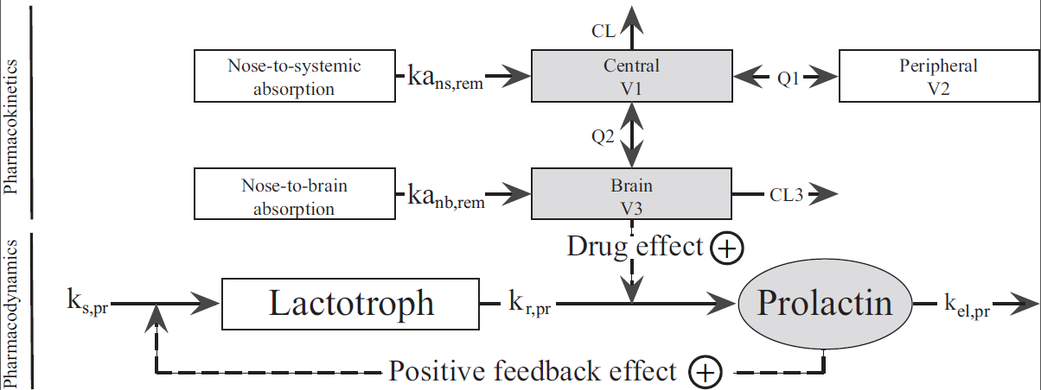

Differential equations for remoxipride concentrations, and differential equations and baseline values for the effect were used. For equilibrium binding dissociation constant of remoxipride for the D₂-receptor literature value was used.
PK–PD model evaluation
Bootstrap procedure, in which the final model was optimized on at least 1000 datasets obtained by random sampling with replacement from the original dataset, was used to derive the uncertainty in the parameter estimates of the final model. From the bootstrap estimation the median and 2.5th and 97.5th percentiles were obtained to represent the non-parametric 95% confidence limits. The bootstrapped parameter estimates were then used in an internal qualification of the model by means of a visual predictive check (VPC). The VPCs were performed using NONMEM, by simulating 1000 replications of the model and a simulation dataset that contained intravenous dosing information for one individual per dosing regimen.
The model was also externally validated. To this end, a VPC was performed using an external dataset obtained following intranasal administration of remoxipride. 1000 replications of the model and a simulation dataset containing intranasal dosing information for one individual per dosing regimen were generated.
Translation from rat to human
To extrapolate the preclinical pool model to that for the human situation allometric scaling principles were applied to scale the first order rate constants for human prolactin release and -elimination.
The clinical value for baseline prolactin concentration was obtained from literature.
For extrapolation of the positive feedback, to our knowledge, no clinical data were available on the E_{max,pr,hum} and EC_{50,pr,hum}. An empiric approach on translation of these parameters was necessary.
To translate the drug-effect model, the PK of remoxipride in humans was reanalyzed using a two-compartmental approach in NONMEM VI, to obtain PK parameter estimates for volume of distribution (V), clearance (CL) and intercompartmental clearance (Q).
For the human model we wanted to include a specific brain compartment, and therefore we assumed that the brain to plasma distribution of remoxipride in humans would be identical to that found in rats, being reasonable as this process in rats seems to be governed by passive diffusion. Thus, our extrapolation approach included transformation of the two-compartment human model into a three-compartment model, in which the brain compartment was explicitly included to be able to simulate unbound human brain ECF concentrations.

- STRUCTURAL MODEL
  - Name, description, and unit of model variables

BSLsd (ng/mL)
BSLdd (ng/mL)
kr,pr (h-1)
kel,pr (h-1)
Positive feedback model
Emax,pr
EC50,pr (ng/mL)
Drug-effect model
Emax,rem
EC50,rem (ng/mL)
Error
σadd
σprop
ηBSL
CL (L/h)
V1 (L)
Peripheral compartment
Q2 (L/h)
V2 (L)
Brain compartment
Q3 (L/h)
V3 (L)
CL3 (L/h)
Error
σadd,plasma
σprop,plasma
σprop,microdialysate
Vtotal

  - Structural equations

Set of structural equations.

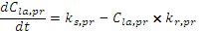 (1)

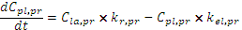 (2)

(3)

(4)

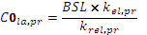 (5)
(6)
(7)
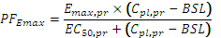 (8)
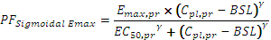 (9)
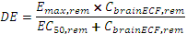 (10)
(11)
(12)
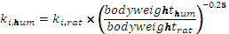 (13)
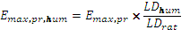 (14)
(15)
(16)

  - Inputs
Provide all needed information to execute and simulate the model, in particular, the characteristics of the model inputs: dose and scheduling of the drugs, initial values of the model variables if these are not include as model parameters.

- STATISTICAL MODEL

  - Residual error model

Write here the equation for the variance of the error, e.g. for constant error model. You can use the general writing

Three types of error models have been used:
Additive Y=Y+ERR
Proportional Y=Y+Y*ERR
Combined Y= Y+ERR + Y*ERR

  - Distribution of individual parameters

Indicate the equation for the individual parameters distribution, e.g. for log-normally distribution

- Additive distribution model:
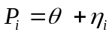
- Exponential distribution model
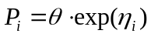
in which P_{i} is the individual value of model parameter P, θ is the typical value (population value) of parameter P, and η_{i} is the random deviation of P_{i} from P. The values of η_{i} are assumed to be independently normally distributed with mean zero and variance ω².

- Proportional error model was chosen to describe the residual error in drug effect:
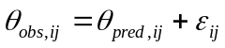
in which θ_{obs,ij} is the jth observed concentration in the ith individual, θ_{pred,ij} is the predicted concentration, and ε_{ij} accounts for the residual deviation of the model predicted value from the observed value. The values for ε_{ij} are assumed to be independently normally distributed with mean zero and variance σ².

- ESTIMATION METHOD
  - Equations solver
If relevant, indicate the method and algorithm for solving the systems of equations.

ADVAN 9

  - Method
Indicate the method and algorithm for parameter estimation.

FOCE with interaction

- DATA DESCRIPTION
  - Analyzed data
Indicate with few lines the type of data that was analyzed and in which context the data have been collected.

  - Number of data points
XXXXXX

  - Number of individuals
XXXXXX

  - Species
Rats, humans.

- MODEL ENCODING FOR DDMoRe
  - Language

NONMEM, because:
    - NONMEM is well validated and well accepted for pharmacokinetic and pharmacodynamic data analysis. If you have PK and PD data that can be analyzed with NONMEM, reviewers and readers will tend to wonder why NONMEM wasn’t used.
    - NONMEM allows you to construct a model of reality, and then test that model against measured reality.
    - NONMEM is a tool that permits you to tackle many common statistical and data analysis problems with a considerable amount of flexibility and much more control over the nuances of the statistical analysis than standard statistical routines and software packages.
    - NONMEM can be run in batch mode. As a result, it is possible to do very complex analyses that require multiple regression steps. An example of this is “profiling” one or more variables in a fit. Profiling means calculating the objective function for the “best” fit at different values of a parameter.

  - Code
Provide a brief description of function and code structure.
XXXXXX

  - Encoding environment
Provide if relevant all the details of your encoding environment, e.g. additional softwares or toolboxes used for generating the graphics.
XXDXXX

- CONSISTENCY WITH PUBLISHED RESULTS
  - Reproduction of artworks
Indicate which figures and/or eventually tables from the original article that have been successfully reproduced with the encoding of the model. For each figure or table, provide a short description of the task performed

XXXXXX

  - Inconsistent results
If relevant, list the inconsistent results obtained in pursuing the objective to reproduce the artworks.
XXXXXX

- Suggested additional outputs
Indicate here the eventual additional outputs, not present in the original publication, which you suggest to check for validating the future implementation of the model into the DDMoRe platform.

The current model is developed for 1 D2 receptor antagonist only. Combination of this model with the ones by Friberg et al., Ma et al, etc, to a meta-model for different Dopaminergic drugs

